**ChemXplosion: New Features – Spring 2018**

[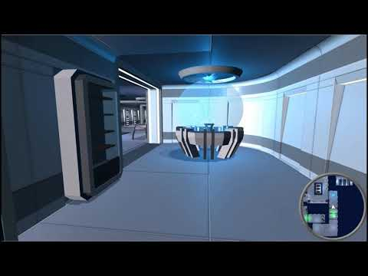](https://www.youtube.com/watch?v=JBfP3A0_Z-U)<https://youtu.be/JBfP3A0_Z-U>